**As part of our commitment to continuously update and enhance our Workplace Philanthropy solution, we have recently added the following features to Campaign Management as general enhancements. In addition, we continue to develop features to support specific needs of client’s programs, and minor bug fixes.**

## Enhancements to the Copy Campaign Tool

The existing copy campaign tool within Campaign Management’s administrative portal (OPPS) was enhanced to allow admins to be able to copy additional data and configuration elements from one campaign to another. Copy campaign allows an administrator to make a copy of an existing campaign to a new campaign under the same company. The additional data elements and configuration sets are available to be copied are displayed in the form of checkboxes. The various data elements and configuration elements not copied include:

* Option Package
* Reporting option package
* Company option Package
* Match Election Set
* Direct Match Option Set
* Volunteer Match option Set
* Donor Group
* Donors/HR data
* Emails - content, and filters
* Batch templates - QPPI
* Batch groups - QPPI
* Users
* Websites (for campaign pledge experience) - this includes images, PDFs
* Designation Panels
* Registration fields
* Application features
* Campaign settings
  + Total Donation Goal ($)
  + Total Donation Adjustment
  + Total Respondent Goal Count Percentage
  + Total Respondent Adjustment Respondents
  + Estimated Potential Donor Count

To Copy Campaigns:

1. Log into CM Administrative Portal (OPPS)
2. Navigate to your specific Campaign
3. Expand the Tools node
4. Click on ‘Add a new Task’
5. Select Copy Campaign from the Tool Type dropdown
6. Select the applicable checkboxes depending upon the needs
7. Click on Save/Update to start the processing.

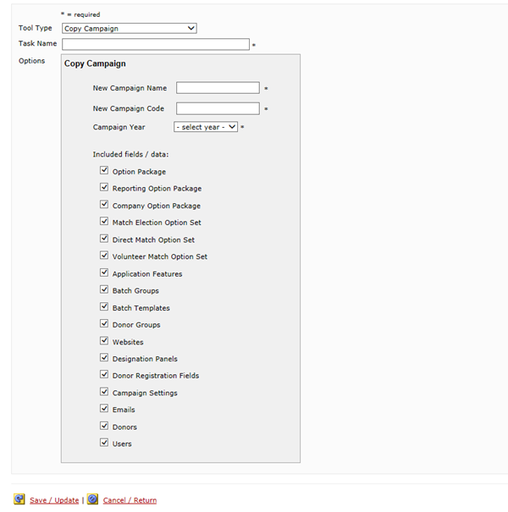

Note: Donation transactions, Special Events, link to Last Year’s Campaign and associated Last Year Total Annual Gift calculation for each donor will *not* be copied from one campaign to another. All transactions of that nature are specific to a campaign.

## Standardized Tax Receipts

Campaign Management now has the capability to display standard tax statements to all donors under the Truist organization. This capability is applicable on SPE, IPE and DPE pledge flows, provided the campaigns use Truist – TDS as the distributing organization. Account Managers/Administrators will need to submit a tech request to enable ‘Tax Receipt’ app feature for the desired company.

To display the tax statement in OPCS, (1) the website must Show Donation History Page and enable Tax History checkbox (2) the admin must import the donor’s contribution data using the ‘Donor Reporting Annual Contribution‘ import from the organization level.

To enable Donation History Page on the website:

1. Log into CM Administrative Area (OPPS)
2. Navigate to your specific Campaign
3. Expand the Website node and >> select the website
4. Click on Content
5. Select Donation History Page from the dropdown
6. Enable the ‘Show Donation History’ and ‘Tax History’ checkboxes
7. Save/Update the configuration

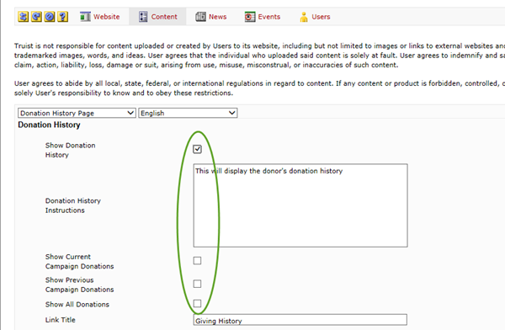

To import Donor’s contribution data in the system:

1. Create an import file with all the relevant donor’s contribution data using the ‘Donor Reporting Annual Contribution’ file specifications.
2. Log into CM Administrative Area (OPPS)
3. Navigate to your specific Organization
4. Expand the Importing node
5. Click on ‘Add a new Import’ and select Import Type as ‘Donor Reporting Annual Contribution’
6. Attach the import file to this task
7. Click on Save/Update to run the task
8. Once the task has successfully completed processing, ensure that the data is available to the donor by impersonating one of the donor as an administrator (if allowed by your user permissions).
9. After both the steps are completed, you should see a link to “Tax Statements” in the main navigation menu.
10. Click on ‘Download Tax statement’ to see the tax receipt. Note: If data was added for multiple years, multiple tax receipts will be displayed (one for each year).
11. The tax receipt is opened as a PDF document in a new window.

The text content of the tax receipts is not editable at this time. The receipt text is approved and provided by the United Way Worldwide.

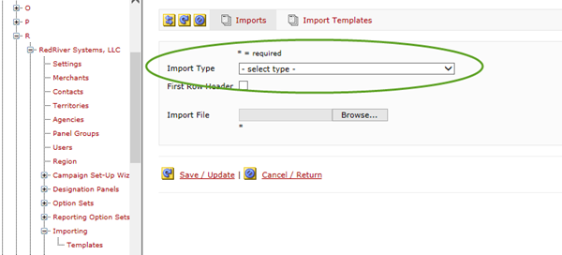

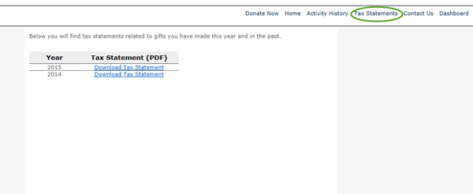

Reminder about Password Guidelines

As you get ready for 2015 giving season, please remember the following password guidelines.

* Password must be between 7 and 15 characters, has no spaces, and contains at least one numeric character.
* Require a minimum length of at least seven characters.
* Contain both numeric and alphabetic characters.
* Acceptable special characters can include (“ ~ ”, “ ' ”, “ # ”, “ [ “,” ^ ”, “ & ”, “ * ”, “ ( “, “ ) “, “ _ “, “ – “,” + “, “ = “, “ [ “, “ ] “, “ { “, “ } ”, “ | “, “ \ “, “ : “, “ ; “, “ /” , “ ? “)

NOTE: “<” or “>” or “!” are no longer acceptable characters