As part of our commitment to continuously update and enhance our Campaign Management solution, we have recently added the following features to our product as general enhancements. In addition, we continue to develop features to support specific needs of client’s programs, and minor bug fixes.

Display donation history for all campaigns and programs

A new check box was created to enable display of giving history for a donor. By default this checkbox is “enabled” for all new campaigns. However, there was no impact to pre-existing campaigns. The ability to display all donations or to display current campaign donations and previous campaign donations is available in any of the three Campaign Pledge flows (SPE, IPE and DPE)
To Enable or Disable donation history,
- Log into CM administrative site (OPPS)
- Select the campaign
- Expand the website node and select the campaign website
- Select Donation History Page
- Created an additional option to show all historical giving history data
- Enable or Disable the “Show All Donations” checkbox. Note: the administrator can select “Show Current Campaign Donations” or “Show Previous Campaign Donations” to limit the donations to a specific campaign.

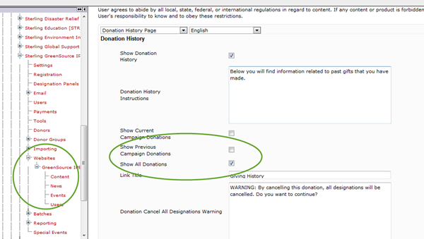

Recognition Program in IPE Pledge Flow
Until recently the recognition program that constitutes part of CM’s Option Sets could not used for the campaign pledge flow – IPE.

As part of Sprint 2, IPE flows can now user Recognition programs and is configured similar to how the program is configured for an SPE flow.

Integration with Frontstream Payment Gateway
Campaign Management is now fully integrated with Frontstream Payment Gateway, Frontstream’s own credit card processing payment gateway. Frontstream Payment Gateway’s advanced gateway technology provides seamless payment solutions for real-time credit card authorizations and exceeds the high security standards set forth by Visa/MasterCard.
Our clients can use Frontstream Payment Gateway as an alternate to Cybersource for processing credit card donations.

Outbound Emails sent using Sendgrid
Campaign Management now used a third party relay vendor named Sendgrid to send all outbound emails from CM. Using an outsourced cloud based SMTP mail server, allows us to build in long term capabilities. It provides Frontstream the ability to manage upgrades and configure software from a central point, provide consistent email capabilities and experience for all its products, and eliminates the extraordinary amount of time and resources spent on maintaining email infrastructure. The new IP address and domain names used by Campaign Management to send emails include:
- Safe IP Address
  - 167.89.21.58
- Safe Domains
  - Truist.com
  - Unitedeway.com
  - Frontstream.com
  - Frontstreampayments.com
  - Createhope.com

