As part of our commitment to continuously update and enhance our Workplace Philanthropy solution, we have recently made the following enhancements to the Workplace Philanthropy Platform.

CM-Argent Integration

As part of CM-Argent integration project, the “Argent” database (aka Charity Database) has now been made available in the Campaign Management system. This FrontStream’s consolidated charity database comprises of all the 501c3, 501c4 and other non-profit organizations that are registered with the IRS.
In Campaign Management, this data is available as an option whenever charities (aka non-profit agencies) need to be selected for configuring a campaign and can be accessed by selecting “Charity Database” as the data source during campaign configurations.
In addition to making the IRS data available, this integration also provides two additional filters that can be used during a campaign’s charity configuration:
- By Category: Charity Database now stores the NTEE codes associated with each NPO in the IRS database. These NTEE codes are categorized into 12 major categories. During campaign configuration, if the campaign uses Charity Database as its source of charity data, the administrator can now select one or more of these categories while configuring their panel group, designation panel or a workplace engagement cause. These categories include:
  - Culture and recreation
  - Education and Research
  - Health
  - Social Services
  - Environment
  - Development and Housing
  - Law, Advocacy and Politics
  - Philanthropic Intermediaries
  - International
  - Religion
  - Business and Professional Associations, Unions
  - Unclassified
- By External Source: The external source identifies where the charity data is sourced from. Currently, the primary source of data is US’s IRS. The long term plans for FrontStream’s consolidated database is to also include publicly registered charities in Australia, UK, Canada and multiple other sources. In order to accommodate these growing sources of data, Argent (aka Charity Database) also includes a filter to identify the source of data. This filter is labelled as “External Source”. Currently, only the “IRS” external source has data that should used.
  - Australia: (future use)
  - CAF America: (future use)
  - Canada: (future use)
  - IRS: Approximately 1.2 million registered charities are available for selection
  - NCES: (future use)
  - UK: (future use)
Note: Do not use ‘GivingStation’ as the external source during campaign, designation panel, or any other charity panel configuration.
Key Items to Note
- When an IRS nonprofit organization (NPO) is used for pledging, CM will no longer treat this IRS registered non-profit as a “write-in”. Any new designations to an IRS NPO will be treated as a regular designation/transaction by CM.
- During data migration, any designations in the system that do not have a corresponding entity identifier nor EINs will be converted into true write-ins.
- Agencies and non-profit organizations from AS400 will no longer be available for any new pledges
- In Designation details (OPPS > Campaign > Donor > Donations > Designation section, the “type” for any designation made to IRS charity will display as ‘Charity database’ and the Entity Id will be a number from 5-7 digits.
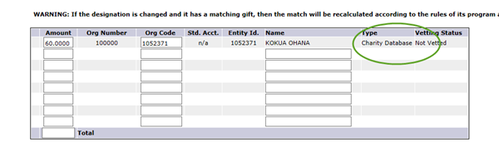
In the administrative portal of CM (OPPS) the following areas will allow Charity database to be used during configuration:

- OPPS > Organization > Panel groups: Charity Database is available as an option when panel group type is Dynamic. Data from Charity database is also available, when the panel group is of standard type, and the administrator clicks on “Add a new Item” or “Bulk add new items” to look for specific charities.
Note: A dynamic panel group can be created using all the charities listed in the Charity Database. At this time, Classic CM does not allow selection of category or external source while creating panel groups.

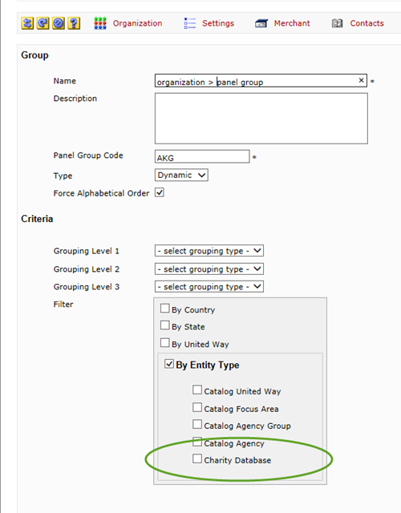

- Addition of “Allow NTEE code” in Search Field Option
In OPPS > Organization > Option Sets > Panel, there is a new Search field option labelled as “Allow NTEE Code”.
The purpose of this new search option (search criteria) is to allow donors to be able to search for agencies and charities using NTEE search criteria.
Currently, only Charity Database supports NTEE categories. This NTEE category data is not available for agencies in iGuide.
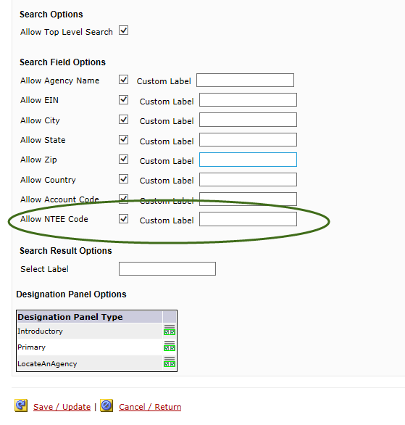

- OPPS > organization > Designation Panels > Items: Charity database is available for both “Add a New item” or “Bulk add new items”.
While creating Designation panels, admin can search for specific charities using Category and External source and add them to the designation panel using “Add a New Item” or “Bulk add new items”.
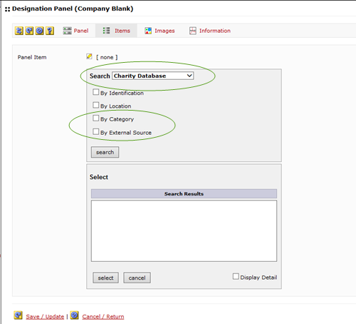

- OPPS > Campaign: If the campaign is Workplace Engagement, then the “Search Configuration” for that campaign will display “Charity Database” as one of the two sources of charity data.
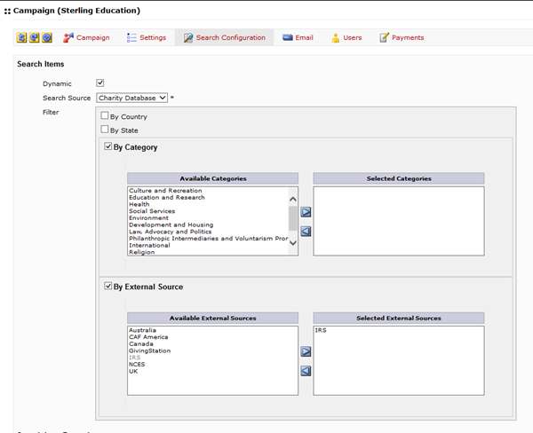

Personal Fundraising Feature for Workplace Engagement

The Workplace Engagement experience, is now integrated with Frontstream’s FirstGiving product. With this integration, companies using Workplace Engagement (aka Sterling), will be able to allow their employees to create their Personal Fundraising pages, and also allow employees to able to donate to each other’s personal fundraisers.
The donations made to any personal fundraisers via Campaign Management will be visible in donor’s Activity History. However, the donations made to personal fundraisers from outside the Campaign Management will not be available in donor’s Giving History.
Given the fact that Personal Fundraising is a company level feature, all fundraisers created by any employee of the company that has access to Campaign Management will be visible to all other employees as long as the fundraiser page was created via Campaign Management platform
Note: This capability was made available for Campaign Pledge experiences in March 2015.
In order to, allow a company to offer this capability, “Personal Fundraiser” feature must be enabled for that company.
How to Configure a Personal Fundraiser for a Company:
- Enable the “Personal Fundraiser” app feature for the company. This is a production support request.
- Once app feature is enabled, in OPPS, activate the “Personal fundraiser page” under website content
  - Go to company node, then go to Websites node , then go to Content tab
  - Under website content, select “Personal Fundraiser Page” in the dropdown
  - Check the ‘Show Personal Fundraisers’
  - Provide any content that needs to be displayed
  - Save and update the configuration

How to View the Personal Fundraiser from the donor end:
- Once the Personal Fundraiser Page has been configured in OPPS for a given company website, all the donors that have access to the website will be able to see a “Fundraiser” section on the homepage.
- Upon login, the very first time, when no fundraisers have been created by any employee at that company, the donors will simply see a Fundraise section on the home page with a widget that says “Start Fundraising”.
- When the employee clicks on the “Start Fundraising” widget, the donor will be seamlessly navigated to the FirstGiving site to first create a personal fundraiser page.
- If the company already has some fundraisers in the system, the employee can click on the ‘Donate’ button associated with any fundraiser to make a donation to any other employee’s personal fundraiser pages.
- On the FirstGiving site, the donor will be able to provide various details to create their personal fundraising page. These details will include:
  - Data to create their FirstGiving Account (using their FirstGiving account, the donor will be able to access their fundraising page directly from FirstGiving.com, as well as share their page with their friends and family)
  - Data to create their Person Fundraising campaign: selecting a charity for their fundraiser, uploading an image, providing their story behind the fundraiser and providing other details as requested by FirstGiving.com.
- Once the Personal Fundraiser page is completed, donor should refresh their website page and should be able to see their personal fundraiser listed on their website’s homepage.
- Any employee of the company will now be able to see and donate to their fundraising page.
- Employees who have created their fundraising page, have made donations to their own fundraising page or made donations to any other employee’s fundraising page will be able to see their personal fundraising transactions in their giving history.
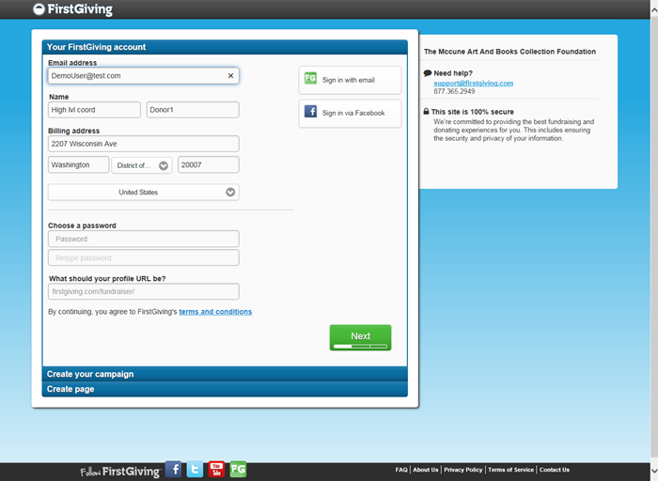

.

Other Enhancements

No-Donation
No Donation is now available as a payment type for Workplace Engagement experience. The payment type is configured at the Organization level under Payment option set similar to any other payment type. Once the option set is configured, the option set should be applied to the required workplace engagement cause.

